Kol Simcha Torah Gazette
For parshas vayera 5786
Vol 10 Issue 7 (Whole #471) 17 Cheshvan 5786/ November 8, 2025
Printed L’illuy nishmas Nechama bas R’ Noach, a”h
For a free subscription, please forward your request to keren18@juno.com
Past emails can be found on the website ShabbosStories.com under Brooklyn Torah Gazette

The Hostage’s Tefillin Wrapped Round the World While Bar Kupershtein Was Trapped in Gaza,
By Yehudis Litvak

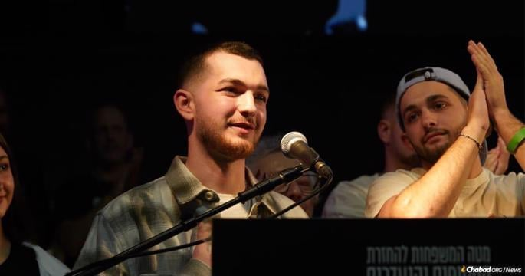
Speaking for the first time at Hostages Square in Tel Aviv on Tuesday night, recently released hostage Bar Kupershtein extended an inivtation for Jewish people to join him wrapping tefillin together on Friday morning.

On Tuesday night, speaking for the first time at Hostages Square in Tel Aviv, recently released hostage Bar Kupershtein extended a moving invitation to the gathered:
“I want to invite everyone this Friday, at 10 o’clock in the morning. I want to organize a mass tefillin laying, where you all put them on together with me. Fulfill my dream with me! My dream was to lay tefillin in captivity. And we’ll do it for the freedom of our brothers still held captive.”
With this invitation, Bar is expanding the tefillin initiative begun by his mother, Julie Kupershtein, while he was held captive by terrorists in Gaza. Throughout the two-year-long ordeal, Julie has been inspiring people worldwide with her steadfast faith and urging Jewish men to lay tefillin in the merit of Bar and other hostages.
Always in the Hands of the Creator of the World
Julie did not choose the spotlight. She is naturally a private person, busy with taking care of her disabled husband, a paramedic who was injured in a car accident, and her five children. When her son Bar was kidnapped by Palestinians on Oct. 7, 2023, she chose not to get involved in politics or the media. Instead, she threw herself into prayers and good deeds in his merit.
As a result of this decision, Julie received a shocking phone call. Speaking in a heavily accented Hebrew, the caller identified himself as a Hamas terrorist holding her son. The terrorist said, “You families of hostages have a lot of power, but you are not doing anything!”
Julie objected, “You don’t know what I do or don’t do. I pray, and I do things that create merits for Bar and other hostages.”
The terrorist threatened that if she wanted to see her son ever again, she must get involved in protesting, criticizing Israel internationally and attempting to topple the Israeli government.
Julie replied, “I am not afraid of you! And my Bar is not in your hands. He is in the hands of the Creator of the World. And you, too, are in the hands of the Creator of the World.”
There was a brief silence on the line, and then the terrorist responded, “Well done, madam!”

Bar’s Tefillin
The conversation with the terrorist strengthened Julie’s faith. She continued to stay away from politics and publicity, intensifying her efforts to bring more mitzvah opportunities to Jews world over.
One of Julie’s requests to her fellow Jews was that Bar’s tefillin remain in continuous use while Bar was unable to use them himself.
In today’s age of social media, Julie’s request instantly spread and received a tremendous response. Julie chose to entrust the tefillin to Tzvika Graiver, an attorney and entrepreneur from Bat Yam, just south of Tel Aviv.
Graiver did not have a personal connection with the Kupershtein family. However, shortly before he heard about Julie’s request, he embarked on his own tefillin initiative, putting up a tefillin stand on the beach near his home, where he used his own pair to encourage others to do the mitzvah. “I put on tefillin every day,” Graiver says. “That’s one of my favorite things to do.” He wanted to share the mitzvah with other Jews and found that people appreciated the opportunity.
When Graiver offered to use Bar’s tefillin for his stand, which he even took with him on his business travels, Julie Kupershtein accepted the offer. Starting in May 2024, Bar’s tefillin embarked on a journey. The entire Graiver family got involved, including his young daughters, who prayed for Bar every day and asked for Bar to come back for their birthday present.
Graiver would set up a small desk with Bar’s picture on it and tell people about Bar’s heroism on Oct. 7. As a security guard, Bar could have escaped the Nova site. Instead, he chose to stay and use his paramedic training to treat the wounded and save lives.

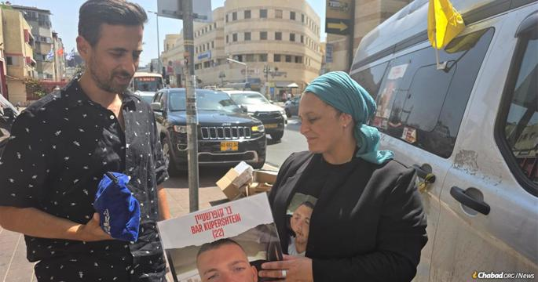
Julia Kupershtein shares her son's tefillin with a Jewish man, whilst he was in captivity and unable to use them.

One of the most poignant moments for Graiver was an encounter on the beach in his hometown of Bat Yam. Graiver offered a young passerby to put on tefillin. At first, the young man wasn’t interested, but when Graiver explained that it belonged to a hostage who was captured at the Nova festival while trying to save lives, the young man agreed.
“I wrapped it on him,” recalls Graiver. “He didn’t know how to do it. He took a tallit, put it on his head and faced the sea.” The young man spent a long time praying. When he finished, he told Graiver that he himself was a Nova survivor.
Another encounter was with two young men who knew Bar from the army. They got very emotional when they put on the tefillin. Graiver, who had never met Bar in person, was moved by the stories the two young men told about him—how Bar would always be the first to volunteer and help whenever there was a need.

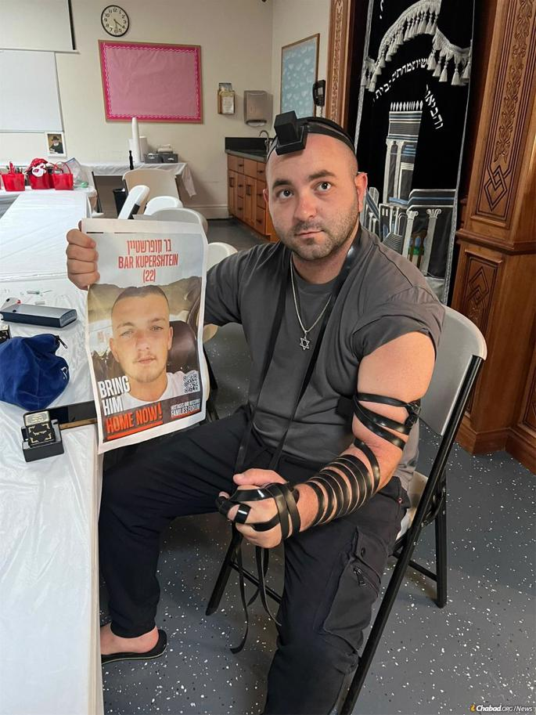
Tzvika Graiver, an attorney and entrepreneur, took Julia's call to heart and brought Bar's tefillin along on his international tefillin travels.

When Graiver was himself called up to the army as a reservist, he took Bar’s tefillin with him and gave his fellow reservists opportunities to don them. Graiver’s experience in Gaza strengthened his dedication to the tefillin initiative. “I saw the tunnels, and I knew that the only way Bar was going to come back would be with G-d’s help and the prayers of the Jewish people,” he says.

Around the world
When Graiver traveled to the United States, Canada, Mexico and Greece on business, he contacted the local Chabad rabbis, who immediately volunteered to help. While Graiver was busy with his work, Chabad rabbis “had my back,” he says. “I knew that the tefillin were in the best hands they could be.”
In Miami, a local Chabad rabbi, with the family’s permission, passed the pair of tefillin all around Florida, with other Chabad rabbis driving for hours to pick it up and return it. The Kupershtein family was happy to see the initiative spreading far and wide with Chabad’s involvement.
When Rabbi Mendy Kaminker of Chabad of Hackensack, N.J., heard about the initiative, he was determined to bring Bar’s tefillin to his community. He made a special effort to travel to La Guardia Airport to pick up the tefillin from Rabbi Yehuda Teichtal of Berlin, who had a few-hour layover at the airport.
Both rabbis filmed an emotional video of the tefillin transfer. “This is very special, very unique, and the entire world is involved in this!” said Rabbi Teichtal.
Rabbi Kaminker posted on social media, inviting people to lay Bar’s tefillin. The response was incredible, he says. “People were crying and praying for the hostages. Everyone wanted to give Bar a hug, but because they couldn’t, they performed a mitzvah that was like a hug. When you hold a holy object that belongs to a hostage, it’s a whole new level of connection. The power of a mitzvah removes all barriers, all physical limitations.”
Jews from all walks of life used the opportunity to lay Bar’s tefillin. Some of them lay it regularly, while others hadn’t done so in decades. A teenage boy put on tefillin for the first time in his life. He was very happy to do something for the hostages.
Chabad of Hackensack’s staff created a video for the Kupershtein family, in which Jews wearing Bar’s tefillin conveyed their prayers and support. An older man with tears in his eyes said, “I’m so honored to be putting it on today for Bar. May he have strength, may you have strength, and may he come home very soon!” A middle-aged woman standing next to her husband, who was wearing Bar’s tefillin, said, “I just want you to know that we have Bar’s picture on our door. We are thinking of him, we are praying for him, and he should only come home healthy and safe very soon!”
When Tzvika Graiver traveled to Georgia, he contacted Rabbi Mendy Gurary of Chabad Israeli Center in Atlanta, who was excited to bring this opportunity to every Chabad House in the state.
Chabad Israeli Center created a beautiful poster with a picture of Bar in a military uniform with his tefillin on. Rabbi Gurary arranged a spreadsheet where rabbis could sign up for a time slot with Bar’s tefillin. Georgia’s Chabad rabbis responded with much enthusiasm, and hundreds of Jews in Georgia had the opportunity to lay Bar’s tefillin.
Chabad Israeli Center hosted a beautiful event, where the attendees took turns laying Bar’s tefillin and participated in prayers for the hostages. “Most of our community is Israelis,” says Rabbi Gurary. “For them to put a hostage’s tefillin on and feel like they’re doing something for the hostages while they’re living in America, and making an impact on their return was very, very powerful.”

Rabbi Gurary describes the excitement he witnessed as people put on Bar’s tefillin akin to that of a bar mitzvah boy laying tefillin for the first time ever. Many of them had not laid tefillin in years. “They really felt like they were holding something holy, something that connects them to the pain and to the hope that [the hostages] would come out because of it,” says Rabbi Gurary.
Rabbi Mendy Wineberg of Chabad of Dunwoody, Georgia, brought Bar’s tefillin to his community for one morning. One of his congregants, Ethan Davidson, described it as “a magical tefillin experience. … The gravity of the moment was heavy, and I felt so connected.”
“It was very real,” says Rabbi Wineberg. “People internalized the idea that they were doing a mitzvah on behalf of Bar, who couldn’t. Living far away and not being able to make a real impact, the opportunity to do something positive and make it a source of inspiration for people was very moving. It brought it closer to home and honed in the feeling that we are all one people who care for each other.”

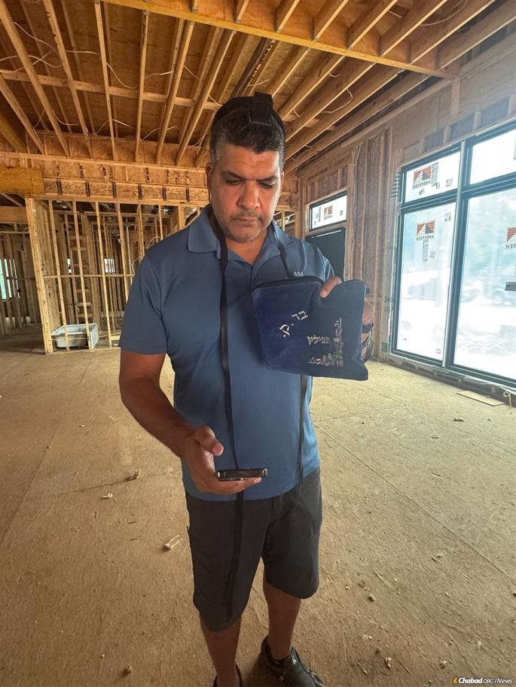
Hundreds of Jewish men in Israel, the United States, Canada, Mexico and Greece performed the mitzvah of tefillin with the tefillin in the merit of the hostages’ release.

Rabbi Dovid Goldschmidt, who heads the CTeen program in Atlanta, brought Bar’s tefillin to a pluralistic Jewish high school. Many boys lined up to put it on. Rabbi Goldschmidt says, “It could seem very far away, what’s happening in Israel and Gaza, but this really brought it actually home, and the boys were very clearly moved to be able to wrap this tefillin.”
Rabbi Goldschmidt reflects that Bar is not that much older than those teen boys, which made the experience all the more meaningful for them. He adds that it’s not easy being a Jewish teenager today. “Especially with teens being on social media, there’s a lot of negativity and hate and just pessimism. It’s very depressing. [Bar’s tefillin] really just gave them a lot of hope, it gave them a lot of courage and strength, and it brought a smile to their faces.”
Campaign: Tefillin for Every Hostage
As the Kupershtein family watched the impact of Bar’s tefillin on world Jewry, they decided to expand the initiative, encouraging Jewish men who do not regularly lay tefillin to commit to putting it on every day in the merit of their son or another hostage.
The campaign, called Tefillin for Every Hostage, aimed to ensure that for every hostage held in Gaza, there would be another Jew in the world laying tefillin daily for as long as the hostage is unable to do so. Donors stepped up o provide tefillin for the volunteers. The initiative spread far and wide, with tefillin stands with hostages’ pictures popping up all over Israel.
Last June, Israel’s President Isaac Herzog hosted an emotional gathering in support of the Tefillin for Every Hostage campaign. The gathering was attended by the Kupershtein family and other hostage families.
At the event, Herzog said: “I wish for all of us to continue doing everything possible to bring everyone home—all of them, down to the last one. Let us cry out, demand, insist, tear open the gates of Heaven, and bring them home. … I put on tefillin every day. We are all praying for their return, and I am confident that our prayers will be answered.”
The prayers and well wishes coming from all over the world were fulfilled this past Sukkot, when Bar was released together with the other living hostages. Videos of his tearful reunion with his family evoked emotional responses all over the world.
Those who had an opportunity to lay Bar’s tefillin felt especially elated. Rabbi Gurary says, “When we announced Bar’s release in our community, it gave people a feeling that by doing something good, by doing a mitzvah, you could change the world.”
For Tzvika Graiver, seeing Bar come home was the most satisfying experience of his life. The Graiver family went to visit him. “It was like meeting our son, our brother, a beautiful and exciting moment,” says Graiver. His 4-year-old daughter was the first to recognize Bar from the picture on the tefillin stands. Graiver returned Bar’s tefillin to him in another emotional reunion.
Graiver feels grateful to G-d for his role in Bar’s story. “I feel that I was chosen for a very important mission,” he says. “The Jewish people came together for this [initiative], and by doing that, they managed to bring Bar home. It shows that if the Jewish people want something and we gather together, nothing can stop us.”
For Tzvika Graiver, seeing Bar come home was the most satisfying experience of his life. Graiver returned Bar’s tefillin to him in another emotional reunion.

Reprinted from the current Chabad.Org website.

Rav Avigdor Miller on
Fighting Communism

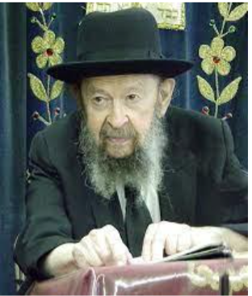

QUESTION: You’re telling us that in order to be loyal to the Torah we have to keep far away from imitating the ways of our gentile neighbors. What do you say about patriotism; about being loyal to the American government?
ANSWER: Now, by no means do I want that you should get the impression that in this place you’re being urged to disregard the interests of the government. Today more than ever before, Jews must raise the flag of patriotism because the nation is actually being endangered by the revolutionaries. And if you would listen to me, you would take the trouble to go to the bargain store and buy a little flag and hang it out when legal holidays or government holidays come around. I did it myself.
I never had a flag but last summer I went and bought a flag and I especially carried it home – I didn’t take the bus on purpose. I wanted to make a demonstration so I carried it through the streets. I carried it a mile. A big American flag I carried through the streets for a mile — let the eyes of the liberals pop out!

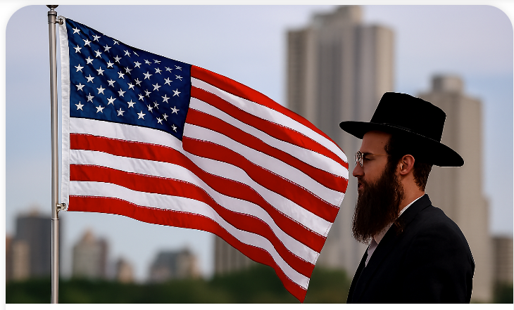
The President [Richard Nixon] asked that we should hang out flags on Flag Day so my flag was out. I never did it before but now is the time. And therefore, nobody should get the impression that patriotism is going to be discouraged here. And I hope my suggestion will bear fruit.
And all this revolutionary talk and attitude among the modern Jews is nothing but assimilation. Only that instead of being assimilated with the good goyim, they’re becoming assimilated with the wicked ones.
I don’t care who ridicules me. I know that there’s ridicule; I know that there’s cynicism. But it’s such a wicked cynicism, such a self-destructive cynicism, that we have to combat it and do just the opposite. We should put American flag stickers on our automobile windows. We should display signs, “We support our boys in Vietnam,” or wherever they are.
All the peace talk is nothing but communist-inspired talk and don’t be deceived about that. All the liberals in the colleges have been tainted by the ferment of communism. Don’t be deceived! They have only one purpose and that is to destroy the country. There are no two ways about it! And don’t think that it’s just silly talk; it’s the plain truth. The communists don’t have to bother anymore. They already put a seed in the minds of all the college people, and the college population today is doing exactly what the communists want. Exactly what they want! They want to break down America.
In the colleges the professors are not only breaking down America but they’re breaking down American society. Today, the construction workers have more good sense than the college professors have. Because who is preaching against marriage? College professors are the ones preaching against marriage. And who’s trying to uphold marriage? The construction workers.
College today means an institution where they take decent people – today we don’t even have that anymore because already in the high schools they did a job on them. So the colleges take people who were once decent when they were three years old and they are making out of them mental cripples. That’s what the colleges are doing. Colleges are a hotbed of anarchism, atheism and destruction.
So at least in one place the truth should be heard. At least in a little corner of Flatbush someone is saying it. Because outside they’re not saying that. Everybody is spouting platitudes that are nothing but imitations of the bums in the street – they want to show that they are also dancing to the tune of the mob.
I know that these lunatics will ridicule me. No matter – we have to fight them with fire; with force if necessary. At least let’s stand up and show that we disapprove of these insane self-destructive attitudes. And although that’s not what I came to speak about tonight, if you came just to hear that it was worthwhile.

Reprinted from a recent email of Torah Avigdor based on a lecture delivered sometime in 1970).

Lessons Learned from Abraham’s Planting
of the Eishel (“Inn”)
From the Teachings of the Lubavitcher Rebbe
Rabbi Menachem Mendel Schneerson, Zt”l


This week's Torah portion, Vayeira, speaks about the greatness of our forefather Abraham, the very first Jew. Through Abraham's service, G-d's Name was made known throughout the world, and many people were brought to believe in Him.
The Torah states: "And Abraham planted an eishel [literally a grove] in Be'er Sheva, and called there in the name of G-d." The Torah specifically mentions Abraham's planting of the eishel, as this was considered a very great deed and a unique accomplishment.
The Midrash explains that an eishel is more than just a stand of trees under which wayfarers may find protection from the burning sun. An eishel is an inn, a place of lodging. Our Patriarch Abraham established his eishel in Be'er Sheva, in the heart of the desert, to cater to travelers in that inhospitable climate.
Did Abraham know these travelers personally? Of course not. He had no idea who might arrive. All he knew was that these strangers would no doubt be hungry, thirsty and tired from their trek across the desert. His motivation was to make their journey more pleasant and less taxing.
Abraham provided his guests with all kinds of amenities, not just bread and water to satisfy their hunger and quench their thirst. His visitors were offered meat, fine wines, fruit and a wide array of delicacies, as well as a place to sleep to rest from their travels.
His visitors' spiritual needs were also taken into consideration. Next to the inn that provided all their physical necessities, Abraham established a Sanhedrin, a court of law, so that wise men could answer the travelers' questions and find solutions to their personal and business problems.
This same attribute of kindness and justice is the birthright of every Jew, an inheritance from our forefather Abraham. And the Torah portion of Vayeira teaches us how we are supposed to fulfill the commandment of charity:
It isn't enough to provide a poor person with the basic requirements necessary to sustain life. We must offer him more than just the bare minimum, bringing him pleasure and enjoyment. And not only must his physical needs be met, but we must also try to help him resolve his spiritual struggles. This applies to every single Jew, even those we do not know personally, and constitutes the true meaning of the commandment of tzedaka (charity).

Reprinted from the Parashat Vayera 5763/2002 edition of L’Chaim, a publication of the Lubavitch Youth Organization. Adapted from Likutei Sichot, Volume 3.

Faith in Full Color:
Half of This Atlanta Congregation is Black
By Rivka Ronda Robinson

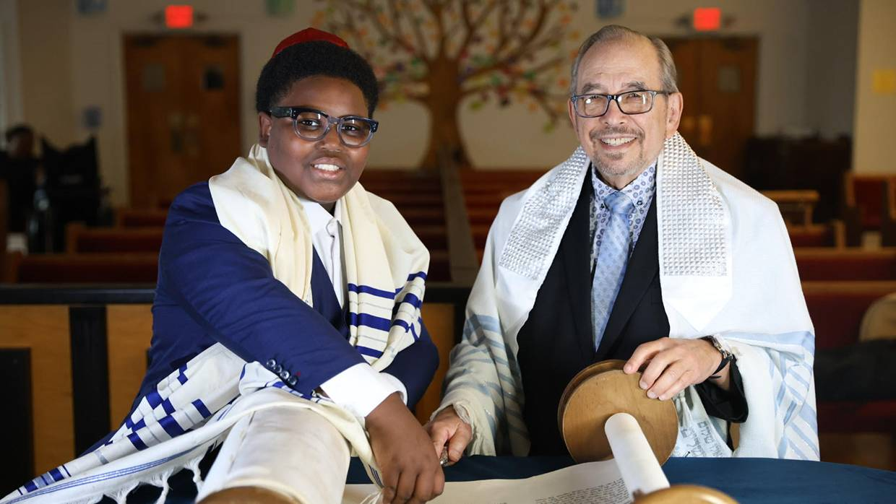
Shaarei Shamayim, a small shul with a big heart, welcomes all Jews from diverse backgrounds.

Hosaha Levy felt that he had a Jewish soul even before converting to Judaism many years ago. He also had a Jewish name.
“My name is not a name change. It’s always been my name,” declares the president of Atlanta’s Shaarei Shamayim synagogue where he is among the 50 percent of the congregants with African-American roots.
The rabbi, Mark Hillel Kunis, describes his congregation as a boutique shul that is welcoming and nonjudgmental. “We have people in our congregation who have heard about Judaism, who had a distant relative who was Jewish, or who have read about Judaism and want to know more,” he says.
The melting pot at Shaarei Shamayim dispels the myth that all members of the tribe are Ashkenazic Jews with roots from Central and Eastern Europe. “Every soul is a holy soul in the image of G-d,” Rabbi Kunis emphasizes.
In 2020 a Pew Research Center survey of demographic trends in the U.S. and the world found that 8% of Jews identify as Black, Hispanic, Asian, another race or multiracial. As Levy can attest, their stories of finding the path to Judaism are as individual as they are.
His father died when Levy was just 18 months old. His grandfather, Augustus, was a deacon at a Baptist church and suggested the name Hosaha. “He loved the book of Hosea, which teaches us about G-d’s unwavering faithfulness.”

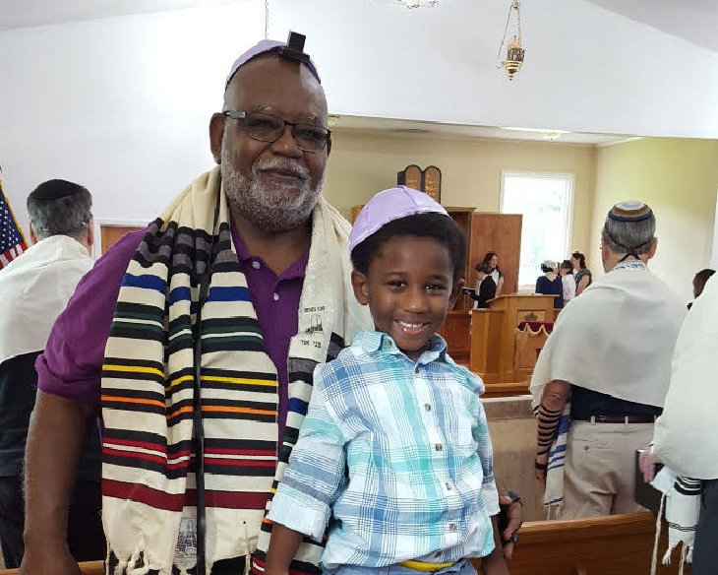
Hosaha Levy at shul with his grandson Jacob

Reared by his mother in a Pennsylvania steel mill town where Jews lived, prayed and ran businesses, Levy had interesting experiences due to his name. As an example, he recalls, “I went for a job at a soda factory. The lady thought, ‘We’re going to get a nice little Jewish boy.’ She looked up and saw me and said, ‘Whoa! ’” The black gentile man was not what she was expecting.

Harlem Synagogue Opens the Door
Coming of age in the 1960s, Levy remembers being part of what he calls “an awakening of black folks wanting to find out about their roots.” A friend from high school who belonged to an African-American synagogue in Harlem introduced him to Judaism.
When Levy, age 25, walked into the New York synagogue in 1976, every fiber of his being felt at home. He has practiced Judaism ever since.
“I came to Atlanta in 1989. I was still observing Judaism but hadn’t gone through conversion. I’d still maintained association with black rabbis in New York. They said I owed my two children a Jewish education. At that point my wife, Darlene, and I went synagogue shopping.”
They walked into a traditional synagogue of 800 families, led at that time by Rabbi Kunis. A congregant named Toni Brown walked up to the Levys and said, “I’m going to take the kids to junior congregation. You go on in to services.”

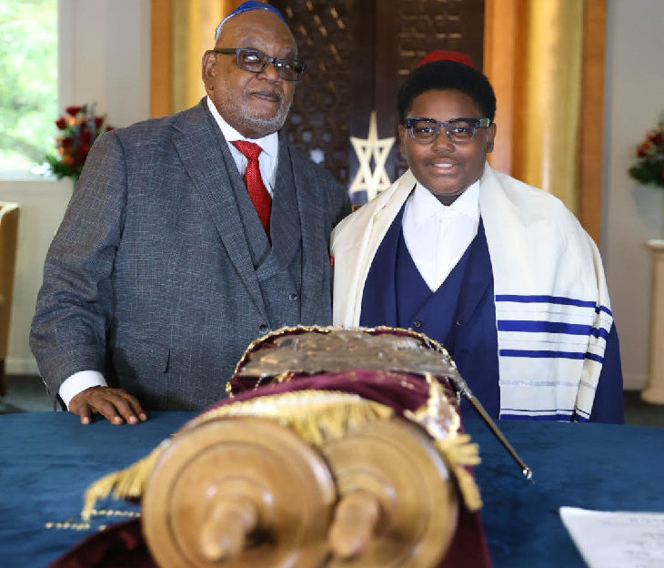
Hosaha with his grandson Jacob celebrating his bar mitzvah

The warm welcome touched Hosaha and Darlene. “That was the first synagogue we went to where someone actually greeted us!” he says.
When members of that synagogue voted to become a more liberal, egalitarian congregation, Rabbi Kunis told them that as an Orthodox rabbi he could no longer serve them. Several of the more traditional members—including the Levys and Toni Brown’s family—broke away to form a new synagogue with Rabbi Kunis at the helm. They launched Shaarei Shamayim on Purim in 2002.
Kunis, who grew up as an Ashkenazic Jew in Brooklyn, candidly remembers: “My family didn’t want to leave Atlanta. It was a blow to my ego, initially, going from 800 families to 30 families.”
But as the years have progressed his boutique shul has quadrupled in size and attracted a mosaic of souls, including African-American converts as well as formerly unaffiliated Hispanic and Israeli Jews.

Embracing the Differences
“We are honored to have them,” says the rabbi. “When we started Shaarei Shamayim we made a greater effort to get them involved in synagogue leadership. There’s a network in the Atlanta area of black Jews and blacks who are interested in Judaism and word started to spread. Some of them had been meeting by themselves but not knowing exactly what to do.
“I make clear to all of them money is no barrier to belonging to Shaarei Shamayim and educating their children in our religious school. People are enthusiastic. I can’t tell you how exciting it is to convert a family of four or six all at once. The excitement on their faces—it doesn’t go away.”

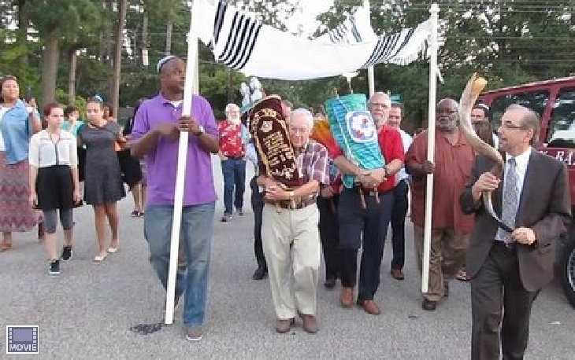Rabbi Kunis, far right, with Hosaha Levy behind him, carrying the Torahs to Shaarei Shamayim’s new building September 2016

The congregation recently honored him with a dinner to celebrate his 50th year in the rabbinate. He clearly has found his mission. When will he retire? “When it stops being fun.”
Says Kunis, the author of Dancing with G-d: How to Connect with G-d Every Time You Pray, “I see and feel Shaarei Shamayim is where I need to be. G-d placed me here for a reason. Part of that reason is to be a spiritual portal to those seeking the light of G-d and Torah.”

Reprinted from the current website of aish.com

